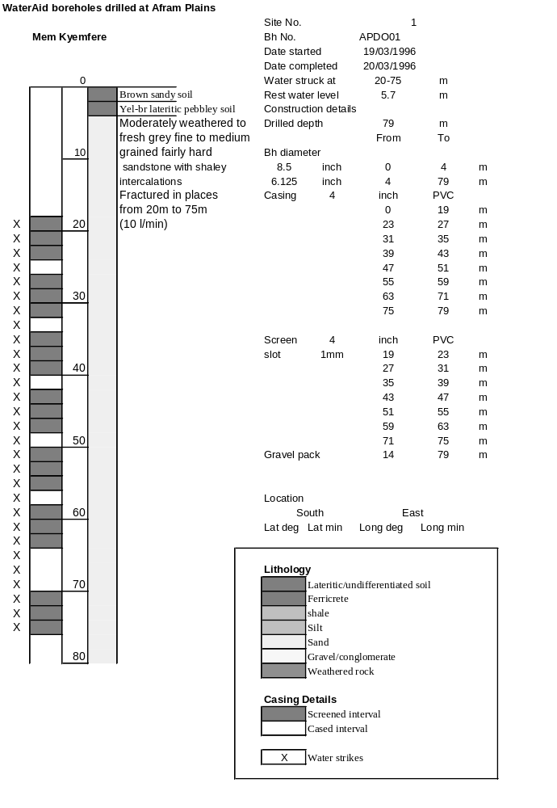
Ghana | Test pumping
Borehole No. |  | APDO1
Hole No |  | 1
Village |  | Mem Kyemfere
Date |  | 12/04/1996
Point above GL |  | 0.5 | m
Pump depth |  | 33 | m
SWL |  | 6.2 | m
Start Time |  | 09:00
Drawdown test |  |  |  |  | Recovery Test
time | pwl (m) | Q l/min | dd | sc | Time | wl (m) | s' | t/t'
0.00 | 6.20 | 5.00 | 0.00 |  | 0.00 | 17.38 | 11.18
1.00 | 9.70 | 5.00 | 3.50 | 1.43 | 1.00 | 16.47 | 10.27 | 181.00
2.00 | 9.90 | 5.00 | 3.70 | 1.35 | 2.00 | 16.18 | 9.98 | 91.00
3.00 | 10.30 | 5.00 | 4.10 | 1.22 | 3.00 | 15.92 | 9.72 | 61.00
4.00 | 11.00 | 5.00 | 4.80 | 1.04 | 4.00 | 15.68 | 9.48 | 46.00
5.00 | 12.25 | 5.00 | 6.05 | 0.83 | 5.00 | 15.44 | 9.24 | 37.00
6.00 | 12.45 | 5.00 | 6.25 | 0.80 | 6.00 | 15.20 | 9.00 | 31.00
7.00 | 12.49 | 5.00 | 6.29 | 0.79 | 7.00 | 14.98 | 8.78 | 26.71
8.00 | 12.57 | 5.00 | 6.37 | 0.78 | 8.00 | 14.77 | 8.57 | 23.50
9.00 | 12.78 | 5.00 | 6.58 | 0.76 | 9.00 | 14.56 | 8.36 | 21.00
10.00 | 12.96 | 5.00 | 6.76 | 0.74 | 10.00 | 14.37 | 8.17 | 19.00
11.00 | 13.11 | 5.00 | 6.91 | 0.72 | 12.00 | 13.99 | 7.79 | 16.00
12.00 | 13.28 | 5.00 | 7.08 | 0.71 | 14.00 | 13.64 | 7.44 | 13.86
13.00 | 13.42 | 5.00 | 7.22 | 0.69 | 16.00 | 13.31 | 7.11 | 12.25
14.00 | 13.55 | 5.00 | 7.35 | 0.68 | 18.00 | 13.00 | 6.80 | 11.00
15.00 | 13.67 | 5.00 | 7.47 | 0.67 | 20.00 | 12.72 | 6.52 | 10.00
16.00 | 13.78 | 5.00 | 7.58 | 0.66 | 22.00 | 12.45 | 6.25 | 9.18
17.00 | 13.87 | 5.00 | 7.67 | 0.65 | 24.00 | 12.21 | 6.01 | 8.50
18.00 | 13.96 | 5.00 | 7.76 | 0.64 | 26.00 | 11.95 | 5.75 | 7.92
19.00 | 14.05 | 5.00 | 7.85 | 0.64 | 28.00 | 11.73 | 5.53 | 7.43
20.00 | 14.22 | 5.00 | 8.02 | 0.62 | 30.00 | 11.48 | 5.28 | 7.00
22.00 | 14.36 | 5.00 | 8.16 | 0.61 | 35.00 | 11.00 | 4.80 | 6.14
24.00 | 14.67 | 5.00 | 8.47 | 0.59 | 40.00 | 10.59 | 4.39 | 5.50
26.00 | 14.96 | 5.00 | 8.76 | 0.57 | 45.00 | 10.23 | 4.03 | 5.00
28.00 | 15.16 | 5.00 | 8.96 | 0.56 | 50.00 | 9.93 | 3.73 | 4.60
30.00 | 15.30 | 5.00 | 9.10 | 0.55 | 60.00 | 9.49 | 3.29 | 4.00
35.00 | 15.49 | 5.00 | 9.29 | 0.54 | 70.00 | 9.05 | 2.85 | 3.57
40.00 | 15.65 | 5.00 | 9.45 | 0.53 | 80.00 | 8.70 | 2.50 | 3.25
45.00 | 15.73 | 5.00 | 9.53 | 0.52 | 90.00 | 8.44 | 2.24 | 3.00
50.00 | 15.82 | 5.00 | 9.62 | 0.52 | 100.00 | 8.28 | 2.08 | 2.80
55.00 | 15.88 | 5.00 | 9.68 | 0.52 | 110.00 | 8.17 | 1.97 | 2.64
60.00 | 15.91 | 5.00 | 9.71 | 0.51 | 120.00 | 8.08 | 1.88 | 2.50
70.00 | 16.11 | 5.00 | 9.91 | 0.50
80.00 | 16.31 | 5.00 | 10.11 | 0.49
90.00 | 16.51 | 5.00 | 10.31 | 0.48
100.00 | 16.70 | 5.00 | 10.50 | 0.48
110.00 | 16.81 | 5.00 | 10.61 | 0.47
120.00 | 16.90 | 5.00 | 10.70 | 0.47
130.00 | 17.00 | 5.00 | 10.80 | 0.46
140.00 | 17.10 | 5.00 | 10.90 | 0.46
160.00 | 17.25 | 5.00 | 11.05 | 0.45
180.00 | 17.38 | 5.00 | 11.18 | 0.45

